Main Interface

Run UpgradeDownload.exe. The main interface is displayed, as shown in Figure 1-1
              - Main interface
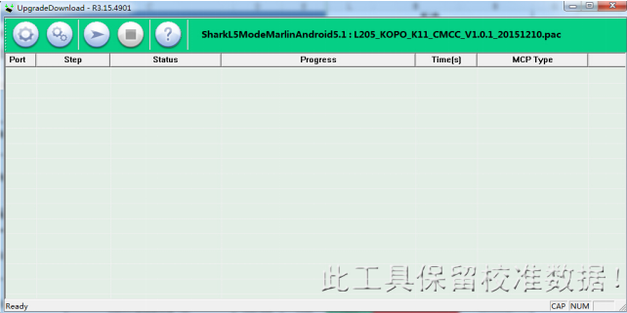

Toolbar
                - UpgradeDownload toolbar icons
Icon | Description
 | Select the packet file to be downloaded.  This icon is unavailable during downloading and turns available after downloading.
 | Detect and open the usable serial port and prepare for downloading.  - Automatic: The program automatically detects the modules connected to the serial port and starts downloading if it finds such modules. After downloading, the program starts detecting again.  - Manual: The program reports the download result after downloading is complete. Downloading starts again after you click this icon again.  This icon is unavailable the first time you run the program and you can start downloading after configuration.
 | Stop downloading. This icon is available when user clicks the Start icon and the usable serial port is open.  Only after downloading is stopped can you exit the program.
 | Version information

1.3 Opening Packets and Configuring Files
Click to open packets to be downloaded and configure files if necessary.

1.4 Starting Downloading
Click . The program automatically starts detecting usable serial ports and opens these ports for downloading. See Figure 1-2-2
Note: long press * when the mobile device is off
              - Download progress
.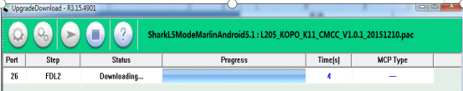

1.5 Downloading Complete
Figure 1-3 shows that downloading is complete.
              - Passed
